

**(Affiliated to Tribhuvan University)**

**Advanced Java Programming**

**Lab 005**

**JDBC, Batch, and Transactions**

|  |  |
| --- | --- |
|  |  |
|  |  |
|  |  |

**Submitted by:**

Abhinna Ojha, 20788/075

BSc. CSIT - VII

**Submitted to:**

Mr. Krishna Pandey

Department of CSIT

# JDBC

## Write programs to create/insert/update/delete/select student table in the db. Student table

## will have the following fields:

## Student ID

## Name

## Class

## Marks.

### Create table

/*

Title:

Create table

Date modified; Author(s); Modification details

2022-02-21; abhinna; Created the program

*/

import java.sql.Connection;

import java.sql.DriverManager;

import java.sql.Statement;

public class CreateTable {

Connection connection;

Statement statement;

public CreateTable() {

try {

Class.forName("com.mysql.jdbc.Driver");

connection = DriverManager.getConnection("jdbc:mysql://localhost:3306/java_student_db", "root", "");

statement = connection.createStatement();

statement.executeUpdate("CREATE TABLE students (id int, roll int, name varchar(100), marks float);");

} catch (Exception exception) {

exception.printStackTrace();

}

}

public static void main(String[] args) {

new CreateTable();

}

}

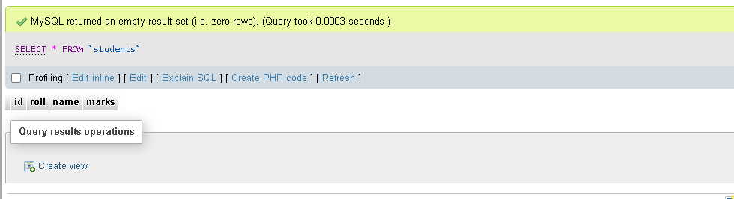

### Insert Records

/*

Title:

Insert Record

Date modified; Author(s); Modification details

2022-02-21; abhinna; Created the program

*/

import java.sql.Connection;

import java.sql.DriverManager;

import java.sql.PreparedStatement;

import java.sql.Statement;

public class InsertRecord {

Connection connection;

Statement statement;

public InsertRecord() {

try {

Class.forName("com.mysql.jdbc.Driver");

connection = DriverManager.getConnection("jdbc:mysql://localhost:3306/java_student_db", "root", "");

statement = connection.createStatement();

statement.executeUpdate("INSERT INTO students VALUES (1, 101, 'Ram', 89.21)");

statement.executeUpdate("INSERT INTO students VALUES (2, 201, 'Shyam', 65.23)");

statement.executeUpdate("INSERT INTO students VALUES (3, 202, 'Hari', 49.66)");

statement.executeUpdate("INSERT INTO students VALUES (4, 203, 'Sita', 53.45)");

statement.executeUpdate("INSERT INTO students VALUES (5, 103, 'Gita', 78.12)");

} catch (Exception exception) {

exception.printStackTrace();

}

}

public static void main(String[] args) {

new InsertRecord();

}

}

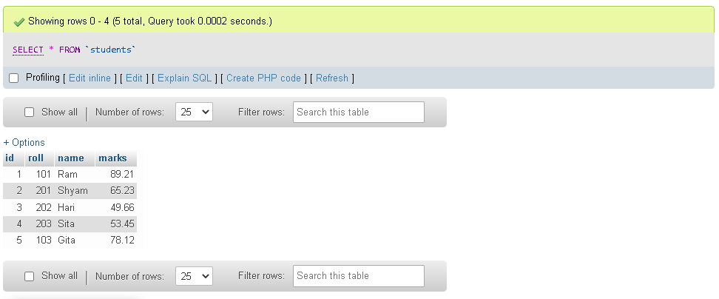

### Update record

/*

Title:

Update record

Date modified; Author(s); Modification details

2022-02-21; abhinna; Created the program

*/

import java.sql.Connection;

import java.sql.DriverManager;

import java.sql.PreparedStatement;

public class UpdateRecord {

Connection connection;

PreparedStatement preparedStatement;

public UpdateRecord() {

try {

Class.forName("com.mysql.jdbc.Driver");

connection = DriverManager.getConnection("jdbc:mysql://localhost:3306/java_student_db", "root", "");

preparedStatement = connection.prepareStatement("UPDATE students SET roll = ?, name = ?, marks = ? WHERE id = ?");

preparedStatement.setString(1, "103");

preparedStatement.setString(2, "Rama");

preparedStatement.setString(3, "84");

preparedStatement.setString(4, "1");

int result = preparedStatement.executeUpdate();

if (result > 0) {

System.out.println("Success");

}

else {

System.out.println("Failed");

}

} catch (Exception exception) {

exception.printStackTrace();

}

}

public static void main(String[] args) {

new UpdateRecord();

}

}

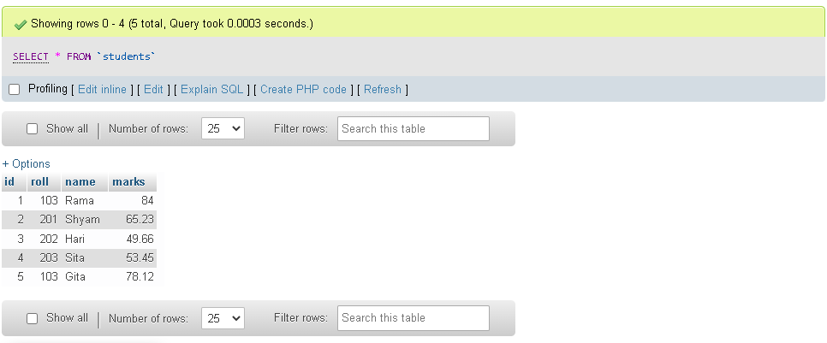

### Select all from table

/*

Title:

Select all from table

Date modified; Author(s); Modification details

2022-02-21; abhinna; Created the program

*/

import java.sql.*;

public class SelectStudentTable {

Connection connection;

Statement statement;

ResultSet resultSet;

public SelectStudentTable() {

try {

Class.forName("com.mysql.jdbc.Driver");

connection = DriverManager.getConnection("jdbc:mysql://localhost:3306/java_student_db", "root", "");

statement = connection.createStatement();

resultSet = statement.executeQuery("SELECT * FROM students");

while (resultSet.next()) {

System.out.println("Student ID: " + resultSet.getString(1));

System.out.println("Student roll: " + resultSet.getString(2));

System.out.println("Student name: " + resultSet.getString(3));

System.out.println("Student marks: " + resultSet.getString(4) + "\n");

}

} catch (Exception exception) {

exception.printStackTrace();

}

}

public static void main(String[] args) {

new SelectStudentTable();

}

}

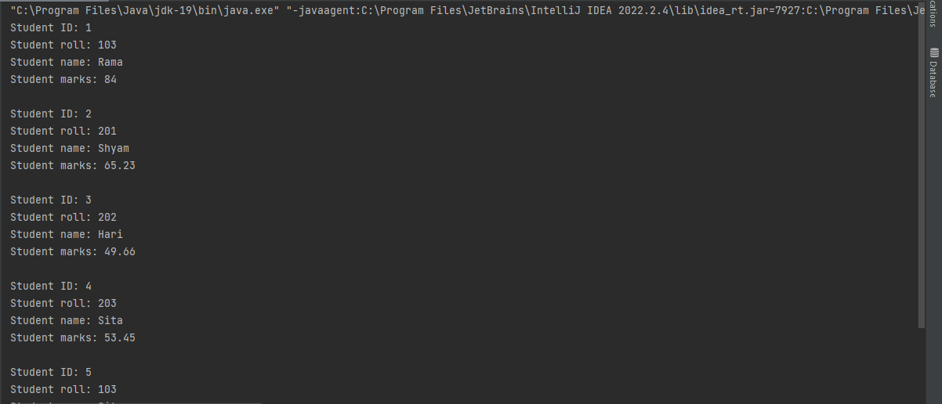

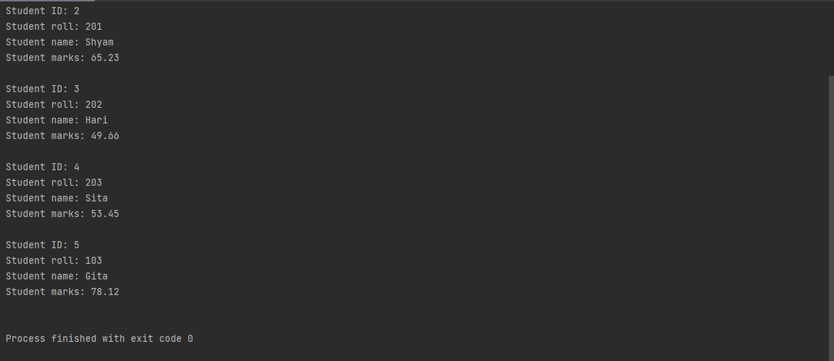

### Delete Record

/*

Title:

Delete Record

Date modified; Author(s); Modification details

2022-02-21; abhinna; Created the program

*/

import java.sql.*;

public class DeleteRecord {

Connection connection;

PreparedStatement preparedStatement;

public DeleteRecord() {

try {

Class.forName("com.mysql.jdbc.Driver");

connection = DriverManager.getConnection("jdbc:mysql://localhost:3306/java_student_db", "root", "");

preparedStatement = connection.prepareStatement("DELETE FROM students WHERE id = ?");

preparedStatement.setString(1, "1");

int result = preparedStatement.executeUpdate();

if (result > 0) {

System.out.println("Success");

}

else {

System.out.println("Failed");

}

} catch (Exception exception) {

exception.printStackTrace();

}

}

public static void main(String[] args) {

new DeleteRecord();

}

}

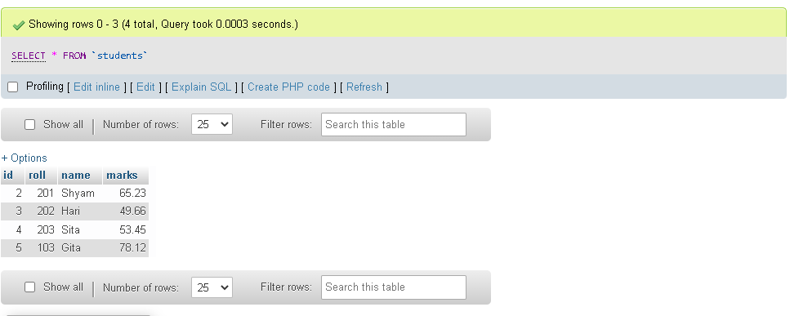

# Write a program to perform Batch processing and Transaction

**management for Student table created in Problem 1**

## Batch Processing

/*

Title:

Batch Processing

Date modified; Author(s); Modification details

2022-02-21; abhinna; Created the program

*/

import java.sql.Connection;

import java.sql.DriverManager;

import java.sql.Statement;

public class BatchProcessing {

Connection connection;

Statement statement;

public BatchProcessing() {

try {

Class.forName("com.mysql.jdbc.Driver");

connection = DriverManager.getConnection("jdbc:mysql://localhost:3306/java_student_db", "root", "");

connection.setAutoCommit(false);

statement = connection.createStatement();

statement.addBatch("INSERT INTO students VALUES (8, 401, 'Sanjay', 87.77)");

statement.addBatch("INSERT INTO students VALUES (9, 411, 'Akshay', 86.99)");

statement.addBatch("INSERT INTO students VALUES (10, 412, 'Suniel', 89.90)");

// execute batch

statement.executeBatch();

connection.commit();;

connection.close();

} catch (Exception exception) {

exception.printStackTrace();

}

}

public static void main(String[] args) {

new BatchProcessing();

}

}

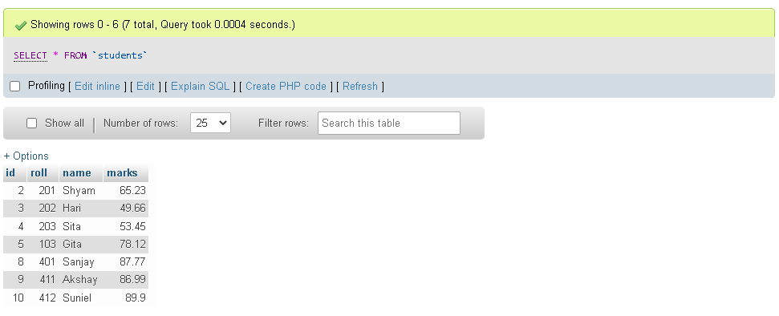

## Transaction Processing

/*

Title:

Transaction Processing

Date modified; Author(s); Modification details

2022-02-21; abhinna; Created the program

*/

import java.sql.Connection;

import java.sql.DriverManager;

import java.sql.Statement;

public class TransactionProcessing {

Connection connection;

public TransactionProcessing() {

try {

Class.forName("com.mysql.jdbc.Driver");

connection = DriverManager.getConnection("jdbc:mysql://localhost:3306/java_student_db", "root", "");

connection.setAutoCommit(false);

Statement statement = connection.createStatement();

statement.executeUpdate("INSERT INTO students VALUES (11, 301, 'Rajesh', 56.66)");

statement.executeUpdate("INSERT INTO students VALUES (12, 312, 'Hritik', 80.33)");

statement.executeUpdate("INSERT INTO students VALUES (13, 313, 'Daniel', 92.34)");

// execute batch

statement.executeBatch();

connection.commit();;

connection.close();

} catch (Exception exception) {

exception.printStackTrace();

}

}

public static void main(String[] args) {

new TransactionProcessing();

}

}

